UNT 3 ASSIGNMENT
Configure a DNS Server and Web Server Using Cisco Packet Tracer.
Name – Sakshi Jarhad
PRN – 2125UCSF1103
Class – Cyber sy
Subject – NPC
1. Aim
The aim of this assignment is to configure a DNS Server and a Web Server in Cisco Packet Tracer and check whether the website works properly.
2. Introduction
In this assignment, I created a small network using Cisco Packet Tracer. I connected two PCs, one switch, one DNS Server, and one Web Server. After connecting the devices, I configured their IP addresses and enabled the required services. Finally, I tested the network and opened the website using its domain name.
3. Devices Used
- Two PCs
- One Cisco 2960 Switch
- One DNS Server
- One Web Server
- Copper Straight-Through cables
- Cisco Packet Tracer software
4. Network Topology
First, I placed all the required devices in the Packet Tracer workspace. Then, I connected both PCs and the two servers to the switch using Copper Straight-Through cables.
Screenshot 1: Network Topology
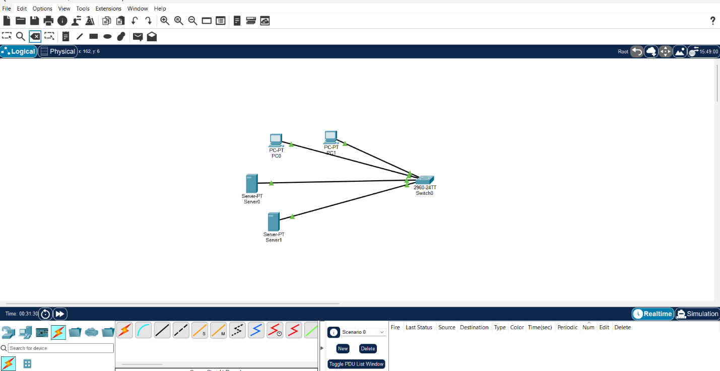
5. IP Address Configuration
After connecting the devices, I assigned IP addresses to them. I selected Static in the IP Configuration window and entered the following details.
Device | IP Address | Subnet Mask
PC0 | 192.168.1.10 | 255.255.255.0
PC1 | 192.168.1.11 | 255.255.255.0
DNS Server | 192.168.1.2 | 255.255.255.0
Web Server | 192.168.1.3 | 255.255.255.0
I also entered 192.168.1.2 as the DNS Server address on both PCs.
Screenshot 2: IP Address Configuration
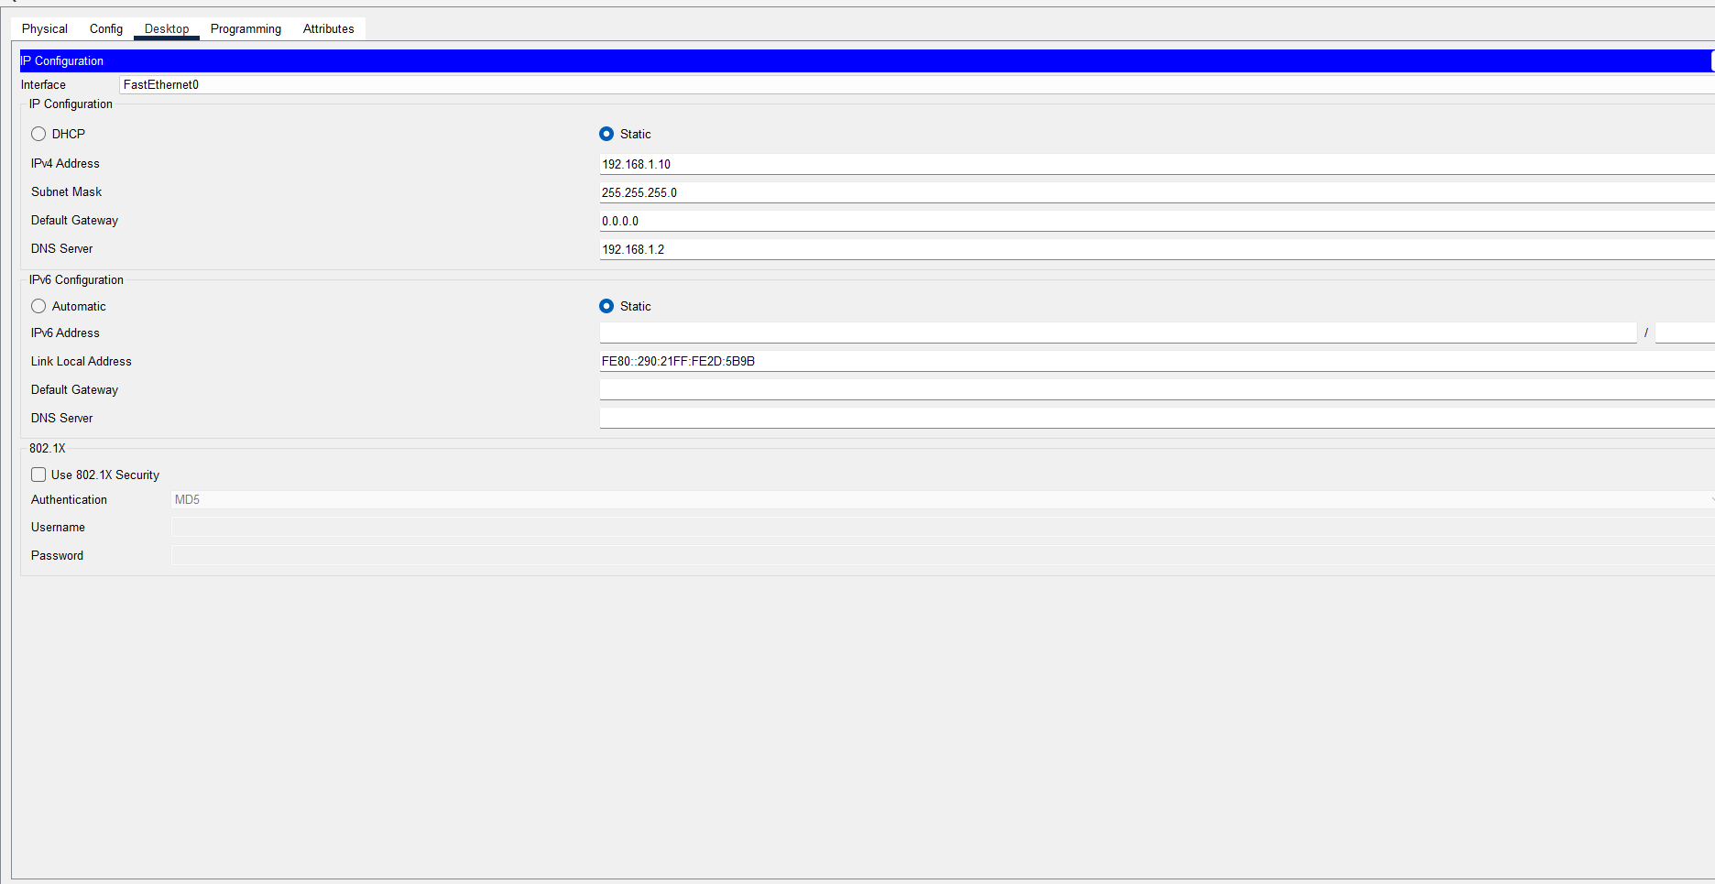

6. Web Server Configuration
Next, I opened Server1 and went to the Services tab. I selected HTTP and turned the service On. This enabled the Web Server to display a webpage.
Screenshot 3: HTTP Configuration

7. DNS Server Configuration
After configuring the Web Server, I opened Server0 and selected Services → DNS. I turned the DNS service On and added the following record.
- Name: www.mycollege.com
- Type: A Record
- Address: 192.168.1.3
I clicked Add to save the record. This connected the domain name with the IP address of my Web Server.
Screenshot 4: DNS Configuration
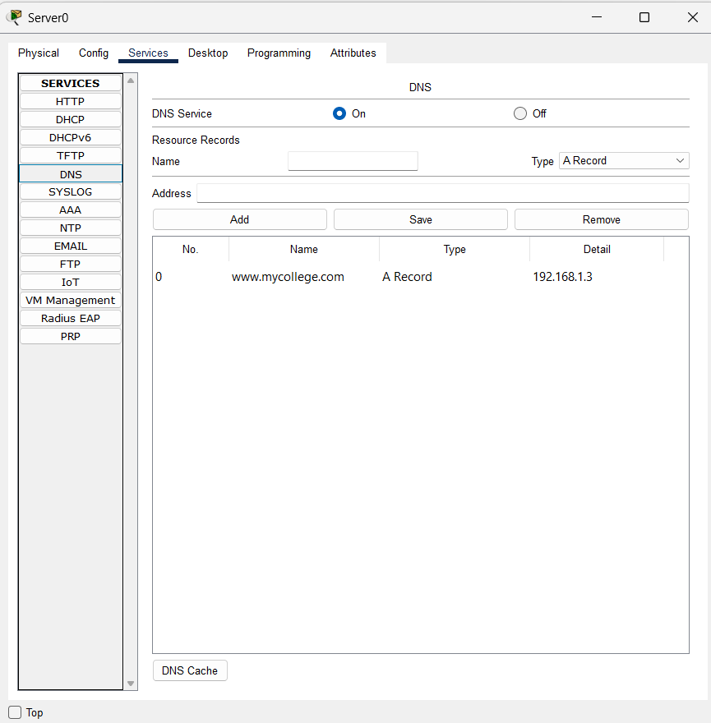
8. Testing the Network
After completing the configuration, I opened the Command Prompt on PC0 and tested the connection using the ping command.
Commands used:
- ping 192.168.1.2
- ping 192.168.1.3
Both tests were successful. I received four packets in each test, and the packet loss was 0%.
Screenshot 5: Ping Test Results
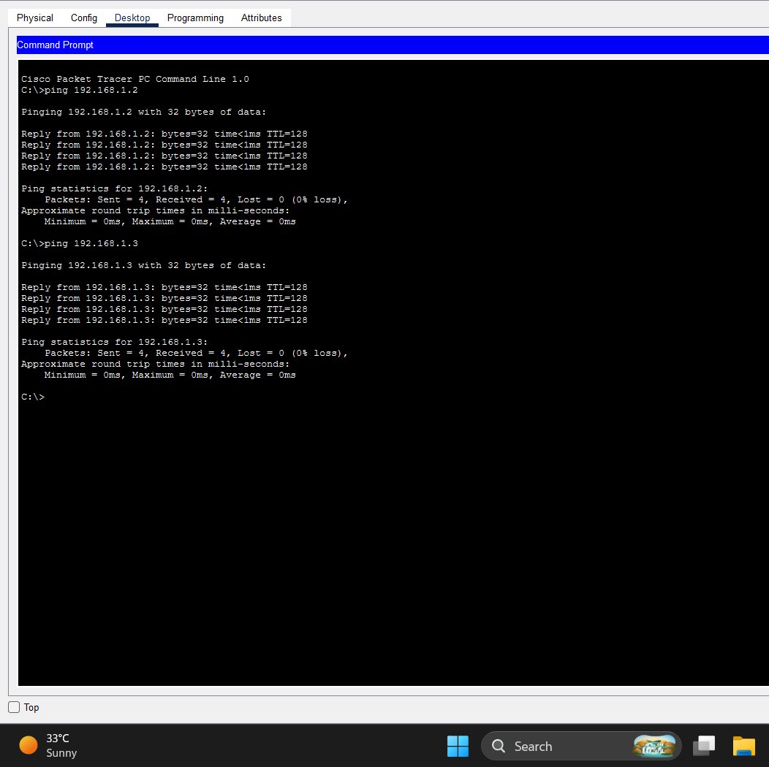
9. Testing the Website
Finally, I opened the Web Browser on PC0 and entered the following address:
http://www.mycollege.com
The website opened successfully. This showed that the DNS Server was resolving the domain name correctly and the Web Server was working.
Screenshot 6: Website Opened Successfully
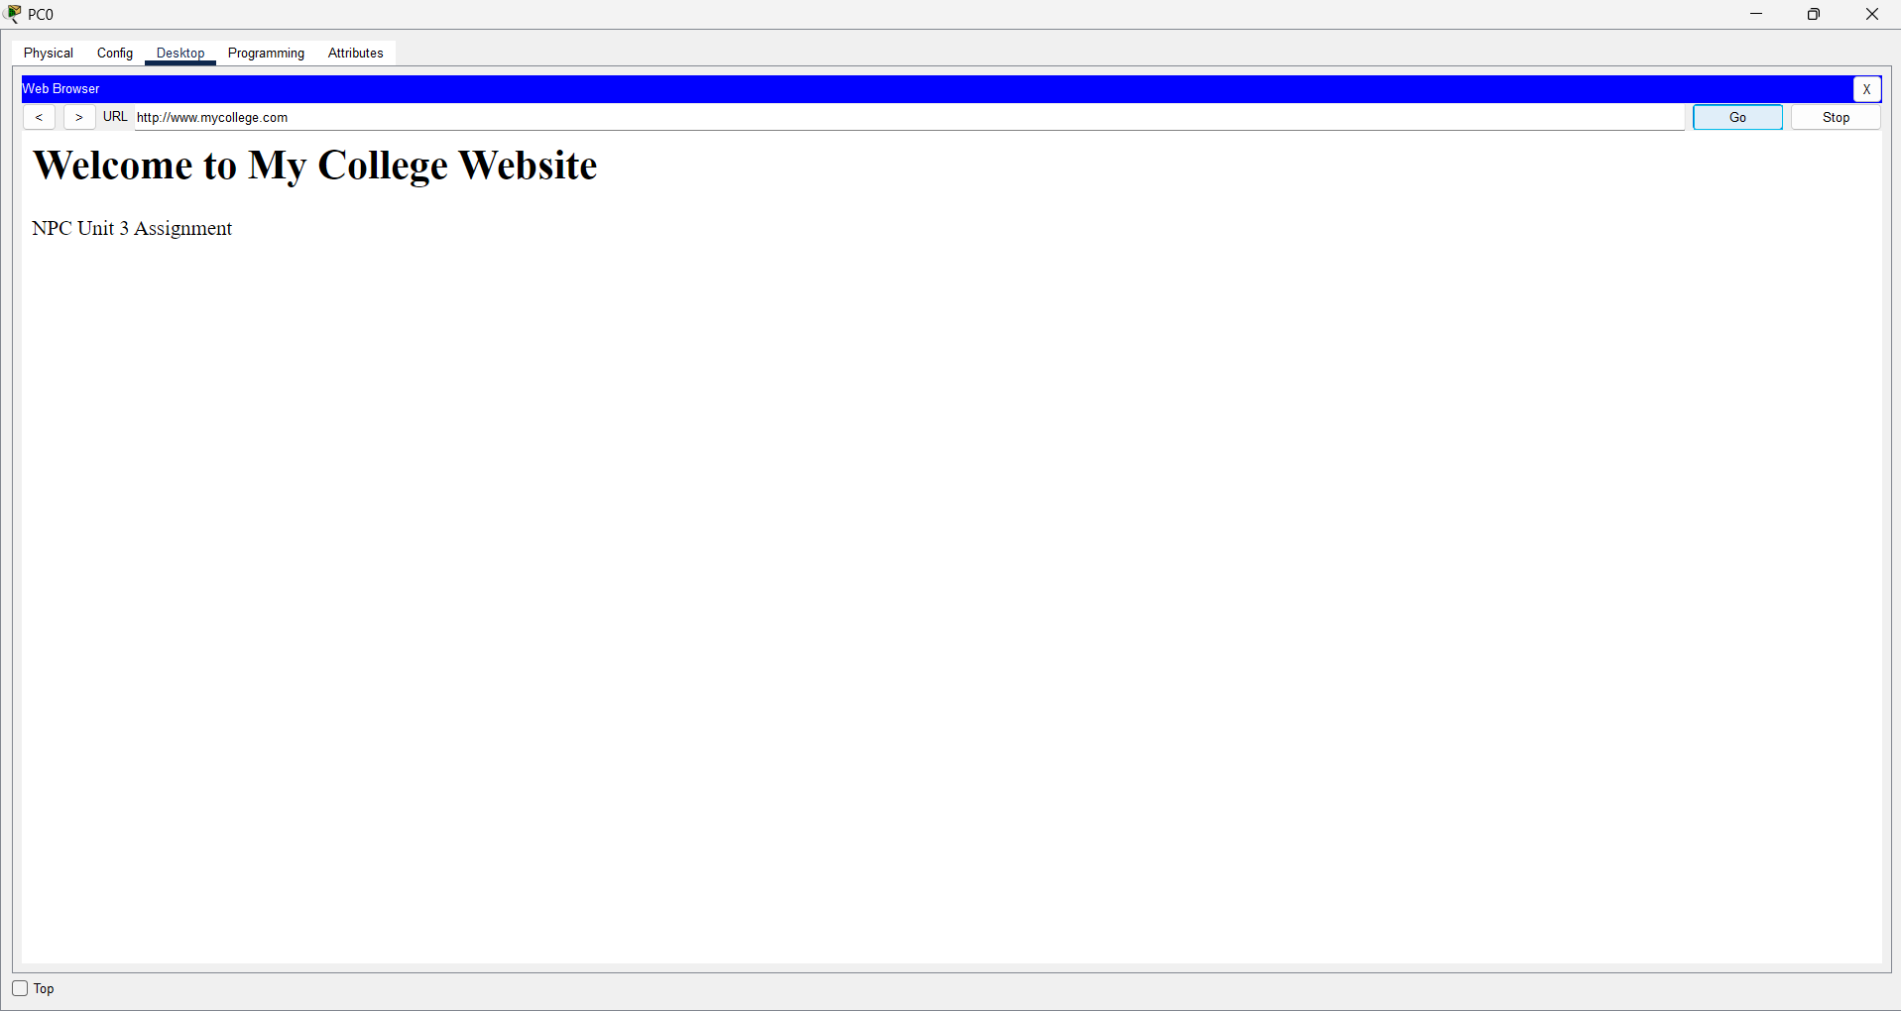
10. Result
I successfully configured the DNS Server and Web Server in Cisco Packet Tracer. I tested the connection using ping commands and opened the website using its domain name.
11. Conclusion
Through this practical, I learned how to connect devices in Cisco Packet Tracer, assign IP addresses, configure DNS records, and enable HTTP services. I also learned how a domain name is used to access a website instead of entering its IP address directly.

